**It is used to access azure blob storage into databrikes using python notebook.**

dbutils.fs.mount(source = 'wasbs://bankdatacon@s3inazure.blob.core.windows.net',

mount_point = '/mnt/blobstorage',

extra_configs = {'fs.azure.account.key.s3inazure.blob.core.windows.net':'t8rxeSuS8SMVsxR8buAJ+NlQvHtDXiGZYkhQEh+QqOijbKAWZz/RPZMYnDiIeT3g1dvuenRHphpW+AStBxItOQ=='} )

To see the content in blob storage

dbutils.fs.ls('/mnt/blobstorage')

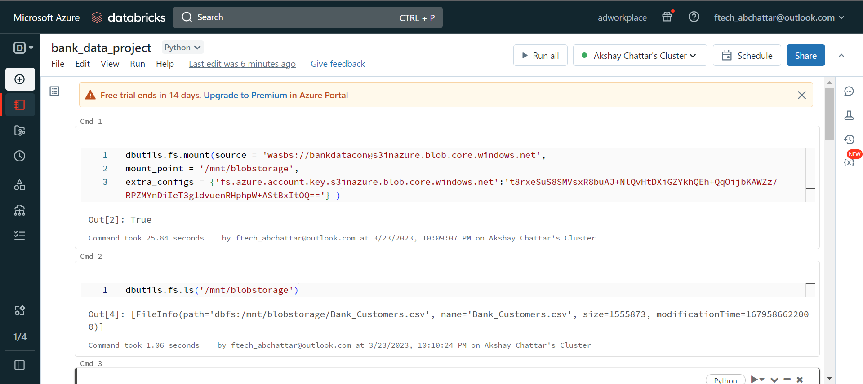

Read the CSV file and create DataFrame

df = spark.read.csv("/mnt/blobstorage/Bank_Customers.csv",header='true')

df.show(10)

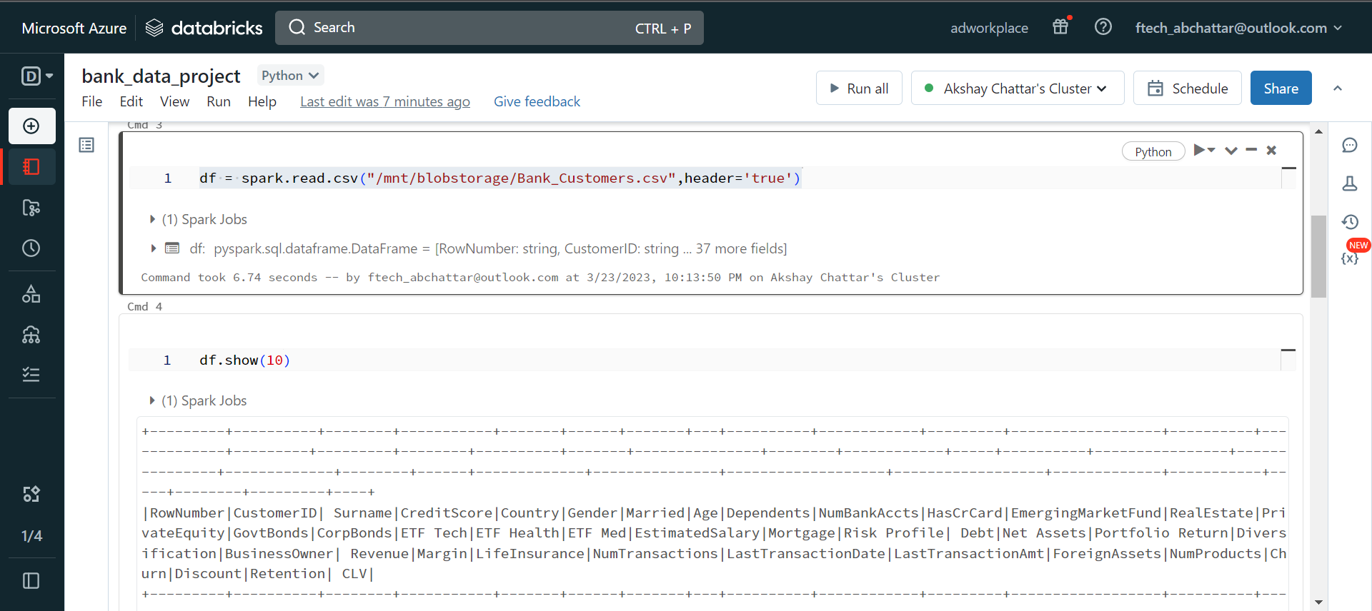

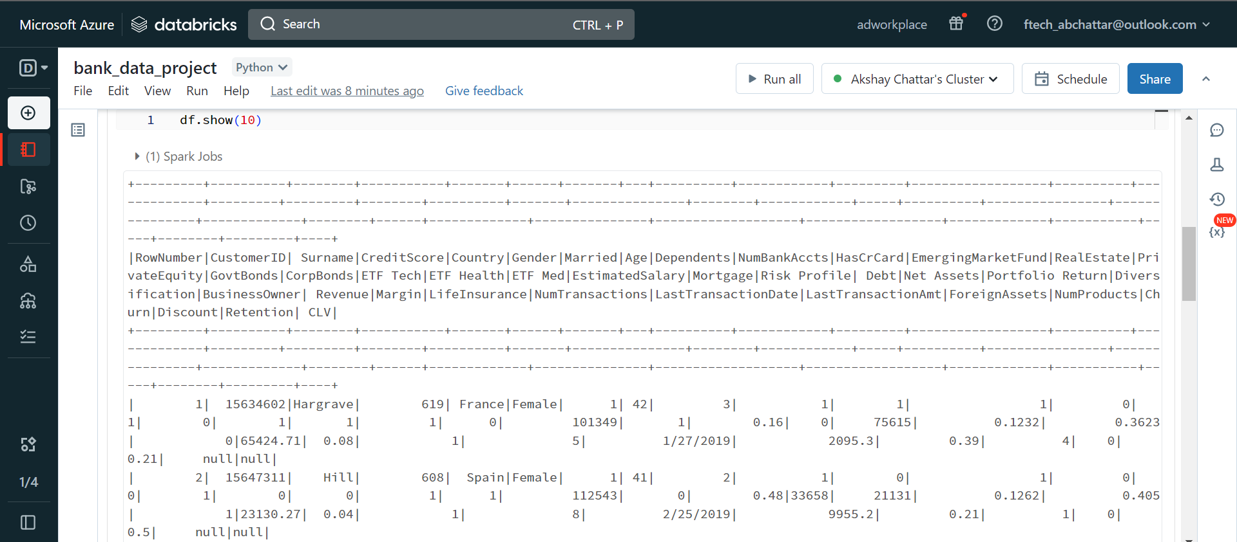

df.createOrReplaceTempView('bank_data')

spark.sql("SELECT male_transactions,female_transactions ,if(male_transactions>female_transactions,'male does more transactions','female does more transactions') as more_transaction_done_by from (select(SELECT cast(sum(NumTransactions) as int) FROM bank_data WHERE Gender= 'Male') AS male_transactions,(select cast(sum(NumTransactions) as int) from bank_data where Gender='Female') as female_transactions)v1").show()

